Pattern Matching
15-3-26
Aim – Write a Python script that prompts the user to enter E-mail and Password. Use regular
expressions to validate the E-mail and Password based on these criteria: Password length should
contain at least 8 characters long and maximum 12. It should have at least one uppercase letter,
one lowercase letter, one digit, and one special character. E-mail should have all small letters.
Theory – This Python program validates an email and password using regular expressions from the re module. The user is prompted to input an email and password, which are then checked against specific patterns. The email pattern ensures lowercase letters, digits, and valid symbols, followed by a proper domain format. The password pattern enforces security rules such as length between 8 to 12 characters, and inclusion of uppercase letters, lowercase letters, digits, and special characters. The re.match() function is used to compare inputs with patterns. Based on validation results, appropriate messages are displayed, demonstrating input validation and basic security checks.

A1.
import re

# Prompt user for email
email = input("Enter E-mail: ")

# Prompt user for password
password = input("Enter Password: ")

# Email validation - all small letters
email_pattern = r'^[a-z0-9._%+-]+@[a-z0-9.-]+\.[a-z]{2,}$'
email_valid = re.match(email_pattern, email)

# Password validation
# At least 8 characters, max 12
# At least one uppercase, one lowercase, one digit, one special character
password_pattern = r'^(?=.*[A-Z])(?=.*[a-z])(?=.*\d)(?=.*[@$!%*?&])[A-Za-z\d@$!%*?&]{8,12}$'
password_valid = re.match(password_pattern, password)

# Display results
if email_valid:
print("✓ E-mail is valid")
else:
print("✗ E-mail is invalid")

if password_valid:
print("✓ Password is valid")
else:
print("✗ Password is invalid")
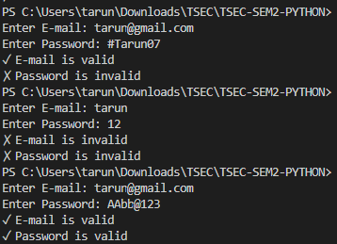
Conclusion
This program demonstrates simple validation using regex, ensuring correct email format and strong passwords for secure user input handling.

